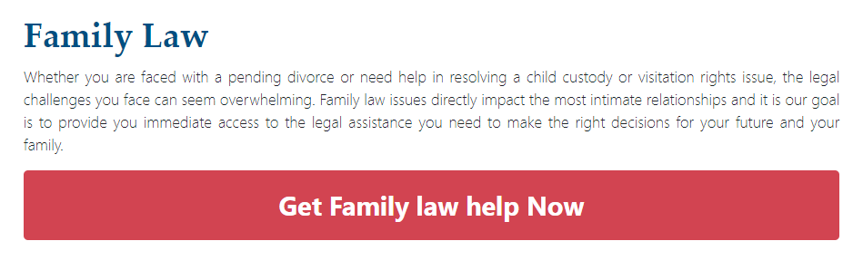

Family Law

If you need help with a divorce, adoption, or other family-related matter, we are the right partner for you. We have some of the best family lawyers in the state ready to advise you and help you through any situation that you might be going through. We understand that these matters are often sensitive and emotional, and we’ll always treat your case with respect.

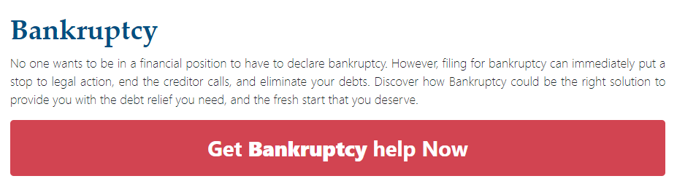

Bankruptcy

Bankruptcy is the last resort, but if it does ever get to that point, give us a call. We have the knowledge and experience to help you navigate this tricky part of your life and ensure tha tyou get the fresh start that you seek.

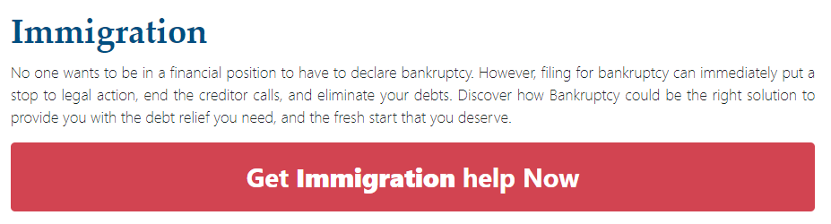

Immigration

If you find your legal status as a citizen in question or you need help gaining a path to citizenship, get in touch with our experienced legal team. We help you navigate the incredibly complex immigration system and help you understand United States laws that pertain to your status in this country.

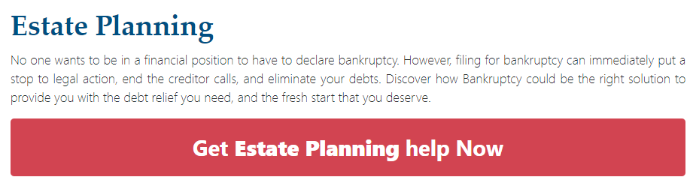

Estate Planning

Estate planning isn’t exactly the most joyous occasion, but it’s an incredibly important part of getting older. By planning your estate, you can leave your relatives in a much better situation and make your wishes clear. We help you make these crucial decisions and put your wishes into a legal document.